PARKINSON’S DISEASE DETECTION

CONTENT
Abstract
1. INTRODUCTION
1.1 Motivation
1.2 Problem Statement
1.3 Objective of the Project
1.4 Scope
1.5 Project Introduction
2. LITERATURE REVIEW
2.1 Previous Studies
3. SYSTEM ANALYSIS
3.1 Existing system
3.2 Limitations
3.3 Proposed System Overview
3.4 Benefits
3.5 Proposed System Workflow
4. REQUIREMENT ANALYSIS
4.1 Functional and Non-functional Requirements
4.2 Hardware Specifications
4.3 Software Specifications
4.4 System Architecture
4.5. Methodology
4.5.1. Convolutional Neural Networks (CNN)
4.5.2. Random forest Classifier
4.5.3. Support Vector Machines
5. SYSTEM DESIGN
5.1 Input Design Overview
5.2 UML Diagrams (Class, Use Case, Sequence, Collaboration, Deployment, Activity, ER, and Component)
5.3 Data Flow Diagram
6. IMPLEMENTATION AND RESULTS
6.1 Module Breakdown
6.2 Output Screens Overview
6.3 Methodology
7. Testing Methods and Test Cases
8. CONCLUSION
9.Future enhancements
10. REFERENCES

Abstract:
Parkinson’s Disease (PD) is a progressive neurodegenerative disorder affecting millions globally, characterized by tremors, stiffness, slowness, and impaired balance. Early detection of PD is crucial for effective diagnosis and management. This project, "Parkinson’s Disease Detection Using Deep Learning Techniques," aims to develop a machine learning model utilizing Convolutional Neural Networks (CNN) and Support Vector Machines (SVM) and Random Forest to analyze speech features from the dataset provided. By focusing on speech characteristics such as frequency, intensity, and timing, the project seeks to improve diagnostic accuracy and support clinical decision-making. The model's implementation could lead to early PD detection, offering benefits such as better treatment options, enhanced patient quality of life, and reduced healthcare costs. Additionally, frequently ask question related to Parkinson’s Disease.
Keywords: Parkinson’s Disease, Speech Analysis, Deep Learning, Convolutional Neural Networks, Support Vector Machines, Early Detection, Diagnostic Accuracy, Machine Learning, Healthcare.

INTRODUCTION
Parkinson’s Disease (PD) is a chronic and progressive neurodegenerative disorder that poses a significant challenge to global healthcare. Affecting millions of individuals worldwide, PD is primarily characterized by a range of motor symptoms including tremors, stiffness, bradykinesia (slowness of movement), and impaired balance. These symptoms, which develop gradually over time, can severely impact the quality of life, making early detection and intervention crucial for effective disease management and improved patient outcomes. Early diagnosis of Parkinson’s Disease is often challenging due to the subtlety of initial symptoms and the variability in how the disease manifests among individuals. Traditional diagnostic methods, which include clinical assessments and imaging techniques, may not always provide timely or accurate results. Thus, there is a pressing need for innovative approaches to enhance early detection capabilities. This project, titled "Parkinson’s Disease Detection Using Deep Learning Techniques," seeks to address this need by leveraging advanced machine learning methodologies.
The primary focus is on analyzing speech features, as vocal characteristics such as frequency, intensity, and timing have been shown to exhibit distinct patterns in individuals with Parkinson’s Disease. By employing Convolutional Neural Networks (CNN), Support Vector Machines (SVM), and Random Forest algorithms, this project aims to develop a robust model capable of detecting Parkinson’s Disease at an early stage through speech analysis. The implementation of such a model holds significant potential benefits, including improved diagnostic accuracy, more effective treatment options, and enhanced patient quality of life. Additionally, it could contribute to reducing healthcare costs associated with late-stage diagnosis and treatment. This project not only aims to advance the field of PD detection but also seeks to provide valuable insights and tools for clinical decision-making.

1. INTRODUCTION
1.1 Motivation:
Parkinson’s Disease (PD) poses significant challenges due to its gradual onset and impact on motor functions. Early and accurate diagnosis is crucial for managing the disease effectively and improving patient outcomes. Our project, "Parkinson’s Disease Detection Using Deep Learning Techniques," aims to address this need by leveraging advanced machine learning models, including Convolutional Neural Networks (CNN), Support Vector Machines (SVM), and Random Forest. By analyzing speech features, which are often altered in PD, we seek to enhance diagnostic precision, facilitating timely interventions and better management of the disease.

1.2 Problem Statement:
Parkinson’s Disease (PD) is a debilitating neurodegenerative disorder with early symptoms that are often subtle and challenging to diagnose. The lack of reliable early detection methods can delay diagnosis and treatment, impacting patient outcomes and increasing healthcare costs. This project addresses the need for an accurate and early diagnostic tool by leveraging advanced deep learning techniques. By analyzing speech features using Convolutional Neural Networks (CNN), Support Vector Machines (SVM), and Random Forest, this project aims to enhance diagnostic accuracy for Parkinson’s Disease, improving patient care and clinical decision-making.
1.3 Objective of the Project:
The primary objective of the project "Parkinson’s Disease Detection Using Deep Learning Techniques" is to develop an advanced machine learning model that leverages Convolutional Neural Networks (CNN), Support Vector Machines (SVM), and Random Forest algorithms to analyze speech features for early detection of Parkinson’s Disease (PD). By focusing on key speech characteristics such as frequency, intensity, and timing, the project aims to enhance diagnostic accuracy, support clinical decision-making, and ultimately improve patient outcomes through early intervention, better treatment options, and reduced healthcare costs.

1.4 Scope:
This project aims to enhance Parkinson’s Disease (PD) detection through advanced deep learning techniques. By employing Convolutional Neural Networks (CNN), Support Vector Machines (SVM), and Random Forest, the project will analyze speech features such as frequency, intensity, and timing to improve diagnostic accuracy. The scope includes developing a machine learning model for early PD detection, which can lead to better treatment options, improved patient quality of life, and reduced healthcare costs. Additionally, it will address common questions related to Parkinson’s Disease for comprehensive understanding.

2. LITERATURE SURVEY

1. Abirami S., Chitra P. (2020). Energy-efficient edge based real-time healthcare support system. Adv. Comp. 117, 339–368. 10.1016/bs.adcom.2019.09.007 [CrossRef] [Google Scholar].
The paper by Abirami S. and Chitra P. (2020), titled "Energy-efficient edge based real-time healthcare support system," focuses on the development of an energy-efficient system for real-time healthcare monitoring using wearable IoT devices. Published in "Advances in Computers," this research delves into strategies for optimizing energy consumption in healthcare applications that require continuous monitoring. The paper explores how edge computing can be leveraged to enhance the efficiency and effectiveness of these systems, ensuring timely and accurate healthcare support. If you need a detailed summary, analysis, or specific insights from the paper, please provide more context or specify the information you are looking for, and I'd be happy to assist further.
2. Al-Fatlawi A. H., Jabardi M. H., Ling S. H. (2016). “Efficient diagnosis system for parkinson's disease using deep belief network,” in 2016 IEEE Congress on evolutionary computation (CEC) (Vancouver, BC, Canada: IEEE; ), 1324–1330. 10.1109/CEC.2016.7743941 [CrossRef] [Google Scholar].
Early diagnosis of Parkinson's disease (PD) is vital for successful treatment and management. This study introduces a diagnostic system that leverages a Deep Belief Network (DBN) to improve diagnostic accuracy while reducing computational demands compared to conventional methods. The DBN is trained on a dataset of PD patients, focusing on identifying key features and recognizing complex patterns associated with the disease. The experimental outcomes show that the DBN achieves high accuracy in diagnosis while remaining computationally efficient. The paper also explores the potential of DBNs in medical diagnosis, emphasizing their importance in early detection and intervention strategies for Parkinson's disease. This research underscores the DBN's capability in enhancing PD diagnosis.
3. Bilgen I., Guvercin G., Rekik I. (2020). Machine learning methods for brain network classification: application to autism diagnosis using cortical morphological networks. J. Neurosci. Meth. 343, 108799. 10.1016/j.jneumeth.2020.108799 [PubMed] [CrossRef] [Google Scholar].
Early diagnosis of Parkinson's disease (PD) is vital for successful treatment and management. This study introduces a diagnostic system that leverages a Deep Belief Network (DBN) to improve diagnostic accuracy while reducing computational demands compared to conventional methods. The DBN is trained on a dataset of PD patients, focusing on identifying key features and recognizing complex patterns associated with the disease. The experimental outcomes show that the DBN achieves high accuracy in diagnosis while remaining computationally efficient. The paper also explores the potential of DBNs in medical diagnosis, emphasizing their importance in early detection and intervention strategies for Parkinson's disease. This research underscores the DBN's capability in enhancing PD diagnosis.

4. Charbuty B., Abdulazeez A. (2021). Classification based on decision tree algorithm for machine learning. J. Appl. Sci. Technol. Trends. 2, 20–28. 10.38094/jastt20165 [CrossRef] [Google Scholar].
You're referring to a paper by Charbuty and Abdulazeez (2021) that explores the use of decision tree algorithms in machine learning, specifically for data classification. The paper, published in the *Journal of Applied Science & Technology Trends*, delves into the significance of decision trees as a method for categorizing data and highlights their various practical applications. The authors discuss how decision trees are widely recognized for their effectiveness in simplifying complex decision-making processes and their adaptability across different types of datasets. The citation you provided includes the DOI link, allowing easy access to the full article for further reading.

5. Fothergill-Misbah N., Maroo H., Hooker J., Kwasa J., Walker R. (2020). Parkinson's disease medication in kenya–situation analysis. Pharmaceutica l J. Kenya. 24, 38–41. [Google Scholar].
Improving the quality of life for Parkinson's disease patients in Kenya requires addressing significant gaps in medication availability and healthcare infrastructure. A study by Fothergill-Misbah et al. (2020) highlights these issues, emphasizing the need for targeted interventions. Key recommendations include increasing financial support for Parkinson’s disease treatments, enhancing the training of healthcare professionals, and developing more effective distribution networks to ensure that medications are accessible to all patients in need. By focusing on these areas, the healthcare system in Kenya can be strengthened, leading to better management of Parkinson’s disease and improved patient outcomes. The study underscores the urgency of these measures to ensure equitable access to necessary treatments across the country.
6. Hossain E., Hossain M. F., Rahaman M. A. (2019). “A color and texture based approach for the detection and classification of plant leaf disease using knn classifier,” in 2019 International Conference on Electrical, Computer and Communication Engineering (ECCE) (Cox's Bazar: IEEE; ), 1–6. 10.1109/ECACE.2019.8679247 [CrossRef] [Google Scholar].
The reference appears to be a citation for a study conducted by Hossain E., Hossain M. F., and Rahaman M. A. in 2019, titled "A Color and Texture Based Approach for the Detection and Classification of Plant Leaf Disease Using KNN Classifier." This study was presented at the 2019 International Conference on Electrical, Computer and Communication Engineering (ECCE) held in Cox's Bazar, and published by IEEE. The research focuses on using color and texture features to detect and classify diseases in plant leaves with the K-Nearest Neighbors (KNN) classifier. The citation also includes a DOI link for easy access to the paper, along with references to CrossRef and Google Scholar for further exploration.

3. SYSTEM ANALYSIS & FEASIBILITY STUDY
Existing System:
Current methods for Parkinson’s Disease (PD) diagnosis primarily involve clinical assessments and neurological examinations, which often detect symptoms only in later stages. Conventional diagnostic tools include motor function tests and subjective evaluations of speech and movement. Although some systems utilize speech analysis, they typically rely on manual feature extraction and traditional statistical methods, which may lack the precision and efficiency of modern machine learning techniques.

Disadvantages of Existing System:
1. Late Detection: The reliance on clinical assessments and neurological exams often results in diagnosing Parkinson’s Disease at a later stage, missing early intervention opportunities.

2. Subjectivity: Motor function tests and evaluations of speech and movement are subjective, leading to potential inconsistencies and variations in diagnosis accuracy.

3. Limited Precision: Traditional diagnostic tools, including manual feature extraction and statistical methods, may not capture subtle or early symptoms effectively, reducing diagnostic precision.

4. Time-Consuming: Manual analysis and feature extraction are labor-intensive and time-consuming, making the diagnostic process less efficient.

5. Lack of Modernization: The current reliance on older diagnostic approaches lacks the advantages of modern machine learning techniques, which could enhance accuracy and early detection capabilities.

Proposed System:
The proposed system aims to enhance Parkinson’s Disease (PD) detection through advanced deep learning techniques. Utilizing Convolutional Neural Networks (CNN) and Support Vector Machines (SVM) and Random Forest, this system will analyze speech features extracted from the dataset to identify subtle patterns associated with PD. By employing these state-of-the-art machine learning algorithms, the system promises more accurate and early diagnosis compared to traditional methods. The CNN will automatically learn and extract relevant features from speech data, while the SVM will classify the presence of PD with high precision. Additionally, and frequently ask question related to Parkinson’s Disease.

Block Diagram

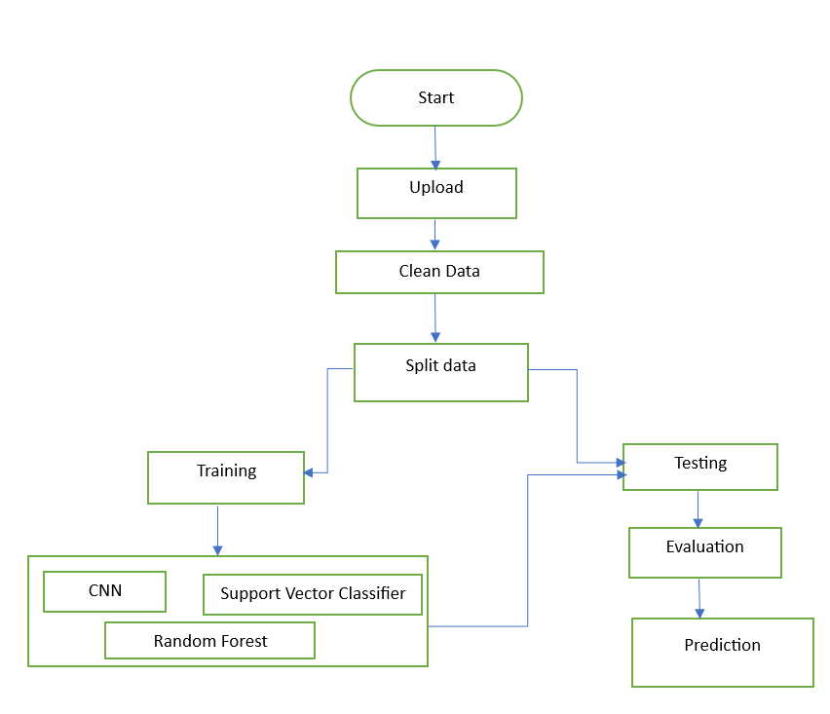

Advantages of Proposed System:
1. Enhanced Accuracy: The combination of CNN and SVM allows for more precise feature extraction and classification, leading to improved accuracy in detecting Parkinson's Disease.
2. Early Diagnosis: The system's ability to identify subtle patterns in speech data enables earlier detection of PD, potentially leading to better patient outcomes.
3. Automated Feature Extraction: The use of CNNs eliminates the need for manual feature engineering, streamlining the detection process and reducing the risk of human error.
4. Robust Classification: Integrating SVM and Random Forest ensures robust classification of PD, offering high precision even with complex and varied datasets.
5. Scalability: The system is scalable and can be adapted to larger datasets, making it suitable for widespread clinical use and research applications.

Architecture:
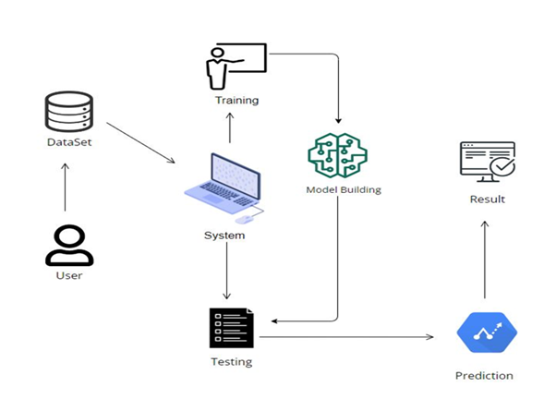

4. SOFTWARE DEVELOPMENT LIFE CYCLE – SDLC:

In our project we use waterfall model as our software development cycle because of its step-by-step procedure while implementing.
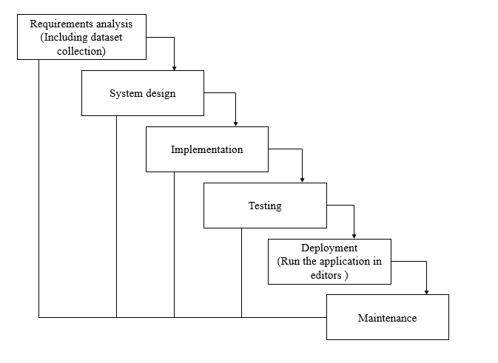
Fig1: Waterfall Model

- Requirement Gathering and analysis − All possible requirements of the system to be developed are captured in this phase and documented in a requirement specification document.
- System Design − the requirement specifications from first phase are studied in this phase and the system design is prepared. This system design helps in specifying hardware and system requirements and helps in defining the overall system architecture.
- Implementation − with inputs from the system design, the system is first developed in small programs called units, which are integrated in the next phase. Each unit is developed and tested for its functionality, which is referred to as Unit Testing.
- Integration and Testing − All the units developed in the implementation phase are integrated into a system after testing of each unit. Post integration the entire system is tested for any faults and failures.
- Deployment of system − Once the functional and non-functional testing is done; the product is deployed in the customer environment or released into the market.
- Maintenance − There are some issues which come up in the client environment. To fix those issues, patches are released. Also, to enhance the product some better versions are released. Maintenance is done to deliver these changes in the customer environment.
FEASIBILITY STUDY
The feasibility of the project is analysed in this phase and business proposal is put forth with a very general plan for the project and some cost estimates. During system analysis the feasibility study of the proposed system is to be carried out. This is to ensure that the proposed system is not a burden to the company. For feasibility analysis, some understanding of the major requirements for the system is essential.
Three key considerations involved in the feasibility analysis are
- ECONOMICAL FEASIBILITY
- TECHNICAL FEASIBILITY
- SOCIAL FEASIBILITY
Economic feasibility:
This study is carried out to check the economic impact that the system will have on the organization. The amount of fund that the company can pour into the research and development of the system is limited. The expenditures must be justified. Thus, the developed system as well within the budget and this was achieved because most of the technologies used are freely available. Only the customized products had to be purchased.

Technical feasibility:
This study is carried out to check the technical feasibility, that is, the technical requirements of the system. Any system developed must not have a high demand on the available technical resources. This will lead to high demands on the available technical resources. This will lead to high demands being placed on the client. The developed system must have a modest requirement, as only minimal or null changes are required for implementing this system.
Social feasibility:
The aspect of study is to check the level of acceptance of the system by the user. This includes the process of training the user to use the system efficiently. The user must not feel threatened by the system, instead must accept it as a necessity. The level of acceptance by the users solely depends on the methods that are employed to educate the user about the system and to make him familiar with it. His level of confidence must be raised so that he is also able to make some constructive criticism, which is welcomed, as he is the final user of the system.

SYSTEM REQUIREMENTS SPECIFICATION

Functional and non-functional requirements:
Requirement’s analysis is very critical process that enables the success of a system or software project to be assessed. Requirements are generally split into two types: Functional and non-functional requirements.
Functional Requirements: These are the requirements that the end user specifically demands as basic facilities that the system should offer. All these functionalities need to be necessarily incorporated into the system as a part of the contract. These are represented or stated in the form of input to be given to the system, the operation performed and the output expected. They are basically the requirements stated by the user which one can see directly in the final product, unlike the non-functional requirements.
Examples of functional requirements:
- Authentication of user whenever he/she logs into the system
- System shutdown in case of a cyber-attack
- A verification email is sent to user whenever he/she register for the first time on some software system.
Non-functional requirements: These are basically the quality constraints that the system must satisfy according to the project contract. The priority or extent to which these factors are implemented varies from one project to other. They are also called non-behavioral requirements.
They basically deal with issues like:
- Portability
- Security
- Maintainability
- Reliability
- Scalability
- Performance
- Reusability
- Flexibility
Examples of non-functional requirements:
- Emails should be sent with a latency of no greater than 12 hours from such an activity.
- The processing of each request should be done within 10 seconds
- The site should load in 3 seconds whenever of simultaneous users are > 10000

SOFTWARE AND HARDWARE REQUIREMENTS:
Hardware:
Operating system : Windows 7 or 7+
RAM : 8 GB
Hard disc or SSD : More than 500 GB
Processor : Intel 3rd generation or high or Ryzen with 8 GB Ram
Software:
Software’s : Python 3.6 or high version
IDE : VSCode.
Framework : Flask

METHODOLOGY AND ALGORITHMS:
Convolutional Neural Networks (CNNs):
Parkinson's disease detection using Convolutional Neural Networks (CNNs) represents a cutting-edge approach in medical diagnostics. CNNs are a class of deep learning models particularly effective for image and signal processing tasks, making them suitable for analyzing medical imaging data such as MRI scans or hand-drawn spiral tests, often used in Parkinson's disease diagnosis. These networks automatically extract features from input data, identifying subtle patterns indicative of the disease that might be missed by traditional methods. CNNs have been trained on large datasets of medical images or gait patterns to distinguish between healthy individuals and those with Parkinson's disease with high accuracy. This technology holds promise for early detection, allowing for timely intervention and improved patient outcomes. By leveraging the power of CNNs, researchers are advancing the field of neurodegenerative disease diagnostics, pushing the boundaries of how we understand and identify Parkinson's disease in its earliest stages.
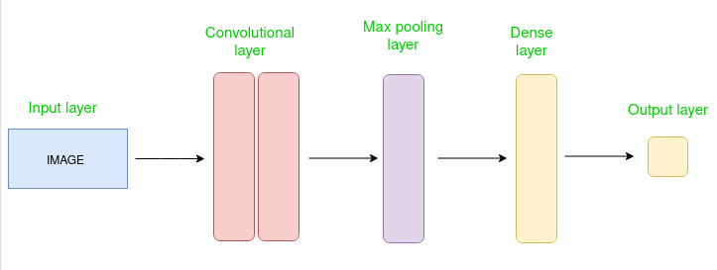

Support Vector Machines (SVM):
Support Vector Machines (SVM) are a powerful supervised learning technique widely used for Parkinson's disease detection. SVMs work by identifying the optimal hyperplane that separates data points belonging to different classes, in this case, distinguishing between healthy individuals and those with Parkinson's. This is particularly effective in handling high-dimensional datasets, which are common in medical diagnostics. The ability of SVMs to handle both linear and non-linear data makes them versatile for modeling complex relationships in biomedical data. In Parkinson's disease detection, SVMs are often employed to classify voice recordings, handwriting patterns, or other biomarkers that exhibit subtle differences between affected and unaffected individuals. By maximizing the margin between classes, SVMs provide robust classification even with small or noisy datasets. Their effectiveness in feature selection and ability to generalize well make SVMs a valuable tool in early and accurate detection of Parkinson's disease, ultimately aiding in timely intervention and treatment.
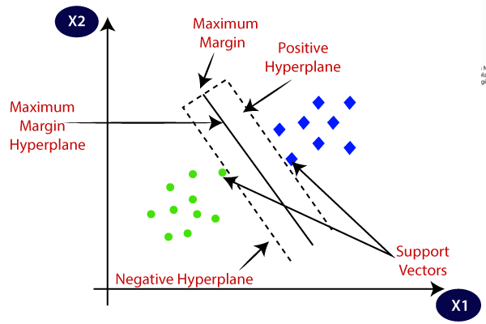

Random Forest:
Random Forest is a powerful machine learning algorithm widely used for Parkinson's disease detection. It operates by constructing multiple decision trees during training and outputting the mode of the classes for classification tasks. In Parkinson's disease detection, Random Forest effectively handles the complexity of clinical and voice data, such as speech patterns, motor symptoms, and other biomarkers, by capturing intricate patterns that differentiate Parkinson's patients from healthy individuals. This ensemble learning method is robust against overfitting, ensuring high accuracy even with noisy or limited data. By averaging the predictions of individual trees, Random Forest reduces variance and improves the model's generalization to unseen data. Its ability to rank feature importance aids in identifying key predictors, enhancing interpretability and supporting medical decision-making. Random Forest's adaptability, scalability, and precision make it a valuable tool in developing reliable diagnostic models for early and accurate Parkinson's disease detection.
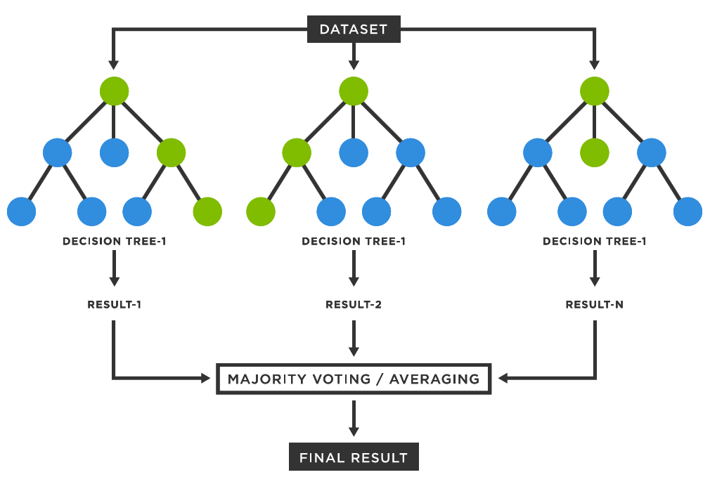
5. SYSTEM DESIGN:

Input Design:
In an information system, input is the raw data that is processed to produce output. During the input design, the developers must consider the input devices such as PC, MICR, OMR, etc.
Therefore, the quality of system input determines the quality of system output. Well-designed input forms and screens have following properties −
- It should serve specific purpose effectively such as storing, recording, and retrieving the information.
- It ensures proper completion with accuracy.
- It should be easy to fill and straightforward.
- It should focus on user’s attention, consistency, and simplicity.
- All these objectives are obtained using the knowledge of basic design principles regarding −
  - What are the inputs needed for the system?
  - How end users respond to different elements of forms and screens.

Objectives for Input Design:
The objectives of input design are −
- To design data entry and input procedures
- To reduce input volume
- To design source documents for data capture or devise other data capture methods
- To design input data records, data entry screens, user interface screens, etc.
- To use validation checks and develop effective input controls.

Output Design:
The design of output is the most important task of any system. During output design, developers identify the type of outputs needed, and consider the necessary output controls and prototype report layouts.

Objectives of Output Design:
The objectives of input design are:
- To develop output design that serves the intended purpose and eliminates the production of unwanted output.
- To develop the output design that meets the end user’s requirements.
- To deliver the appropriate quantity of output.
- To form the output in appropriate format and direct it to the right person.
- To make the output available on time for making good decisions.
UML DIAGRAMS
UML stands for Unified Modelling Language. UML is a standardized generalpurpose modelling language in the field of object-oriented software engineering. The standard is managed, and was created by, the Object Management Group.
The goal is for UML to become a common language for creating models of objectoriented computer software. In its current form UML is comprised of two major components: a Metamodel and a notation. In the future, some form of method or process may also be added to; or associated with, UML.
The Unified Modelling Language is a standard language for specifying, Visualization, Constructing and documenting the artefacts of software system, as well as for business modelling and other non-software systems.
The UML represents a collection of best engineering practices that have proven successful in the modelling of large and complex systems.
The UML is a very important part of developing objectsoriented software and the software development process. The UML uses mostly graphical notations to express the design of software projects.

GOALS:
The Primary goals in the design of the UML are as follows:
- Provide users a readytouse, expressive visual modelling Language so that they can develop and exchange meaningful models.
- Provide extendibility and specialization mechanisms to extend the core concepts.
- Be independent of particular programming languages and development process.
- Provide a formal basis for understanding the modelling language.
- Encourage the growth of OO tools market.
- Support higher level development concepts such as collaborations, frameworks, patterns and components.
- Integrate best practices.

USE CASE DIAGRAM
- A use case diagram in the Unified Modeling Language (UML) is a type of behavioral diagram defined by and created from a Usecase analysis.
- Its purpose is to present a graphical overview of the functionality provided by a system in terms of actors, their goals (represented as use cases), and any dependencies between those use cases.
- The main purpose of a use case diagram is to show what system functions are performed for which actor. Roles of the actors in the system can be depicted.

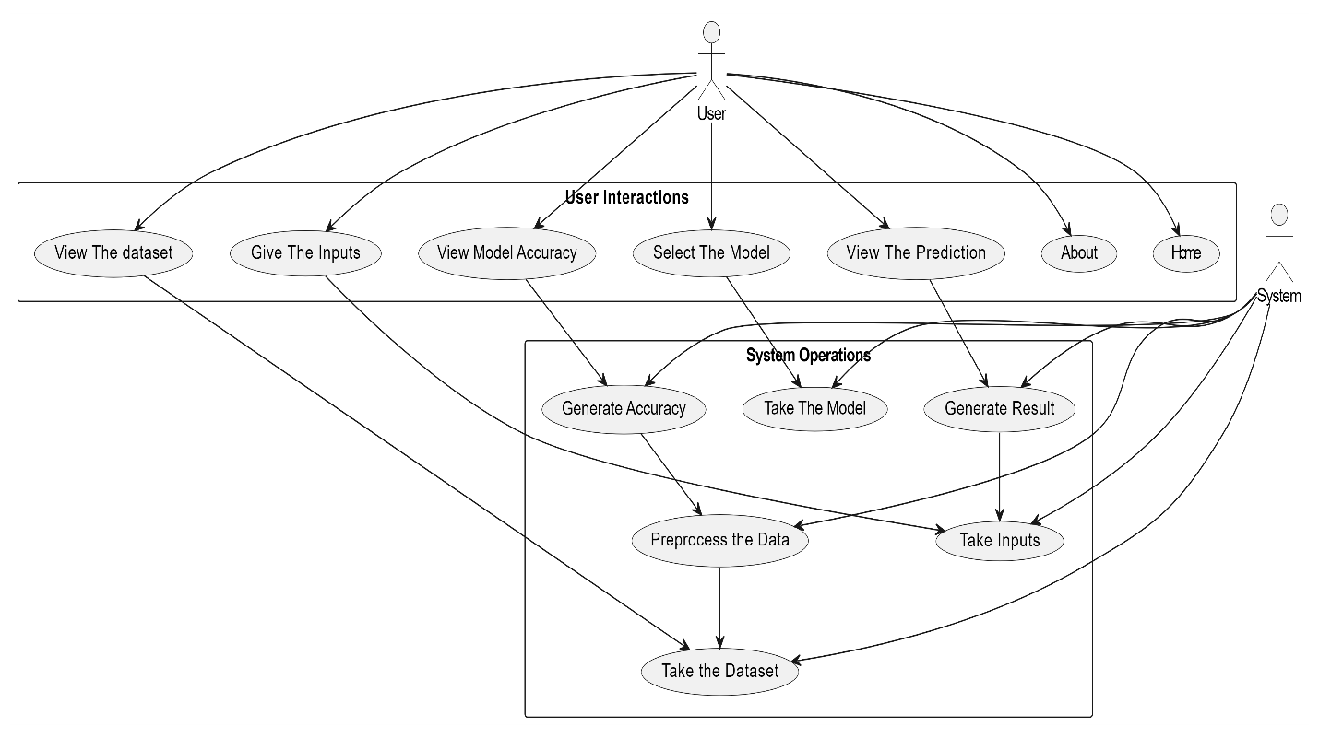

CLASS DIAGRAM
In software engineering, a class diagram in the Unified Modeling Language (UML) is a type of static structure diagram that describes the structure of a system by showing the system's classes, their attributes, operations (or methods), and the relationships among the classes. It explains which class contains information
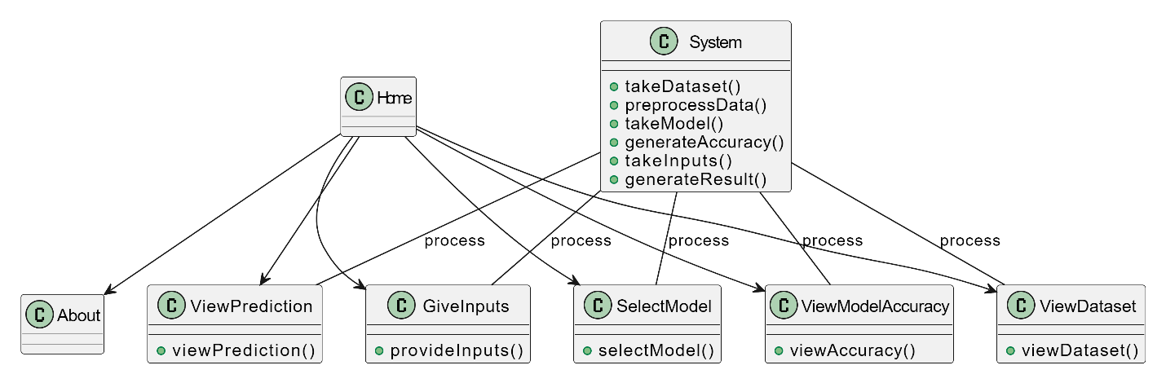

SEQUENCE DIAGRAM
- A sequence diagram in Unified Modeling Language (UML) is a kind of interaction diagram that shows how processes operate with one another and in what order.
- It is a construct of a Message Sequence Chart. Sequence diagrams are sometimes called event diagrams, event scenarios, and timing diagrams
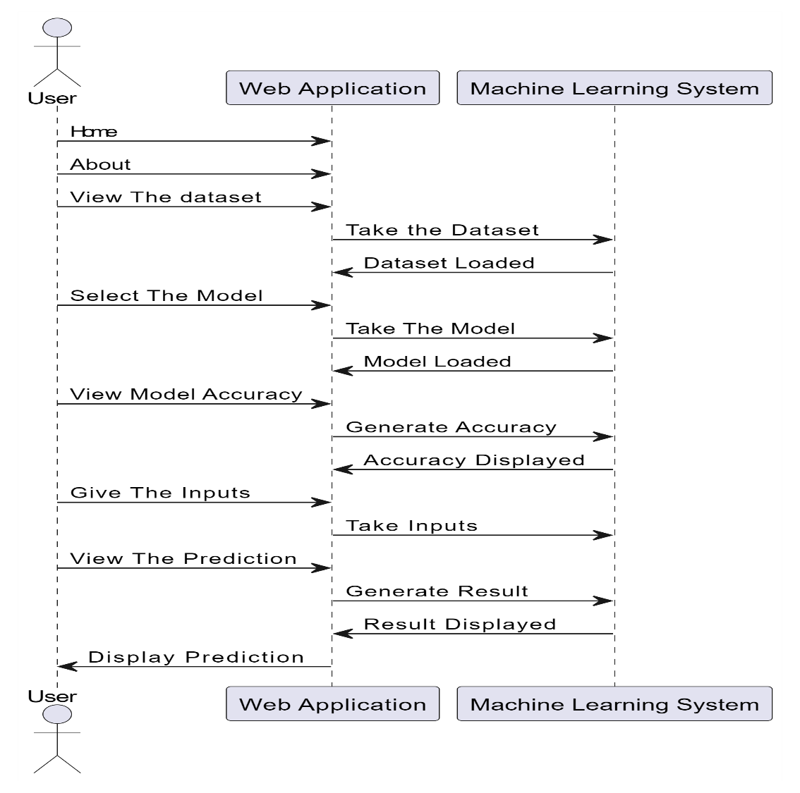

COLLABORATION DIAGRAM:
In collaboration diagram the method call sequence is indicated by some numbering technique as shown below. The number indicates how the methods are called one after another. We have taken the same order management system to describe the collaboration diagram. The method calls are similar to that of a sequence diagram. But the difference is that the sequence diagram does not describe the object organization whereas the collaboration diagram shows the object organization.
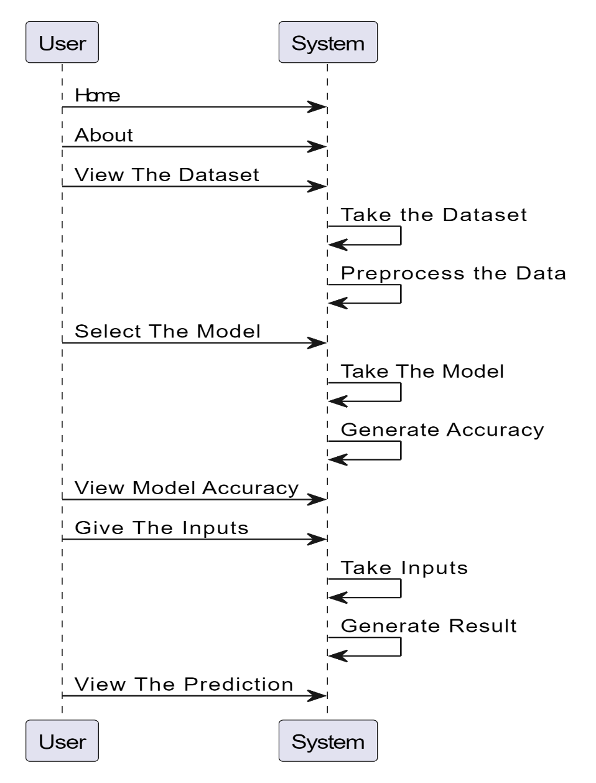

DEPLOYMENT DIAGRAM
Deployment diagram represents the deployment view of a system. It is related to the component diagram. Because the components are deployed using the deployment diagrams. A deployment diagram consists of nodes. Nodes are nothing but physical hardware’s used to deploy the application.
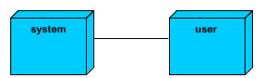

ACTIVITY DIAGRAM:
Activity diagrams are graphical representations of workflows of stepwise activities and actions with support for choice, iteration and concurrency. In the Unified Modelling Language, activity diagrams can be used to describe the business and operational stepbystep workflows of components in a system. An activity diagram shows the overall flow of control.

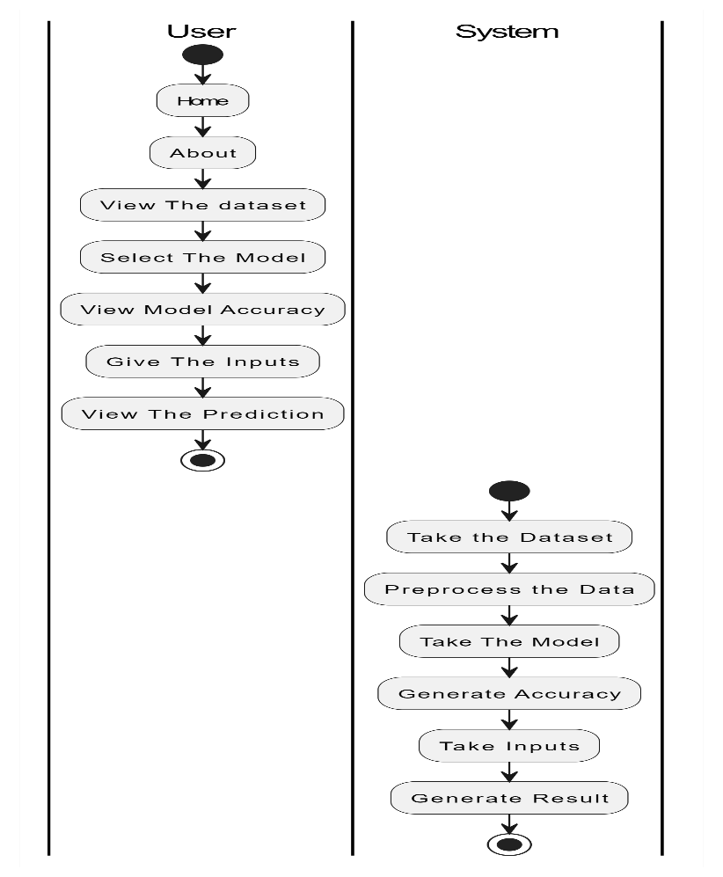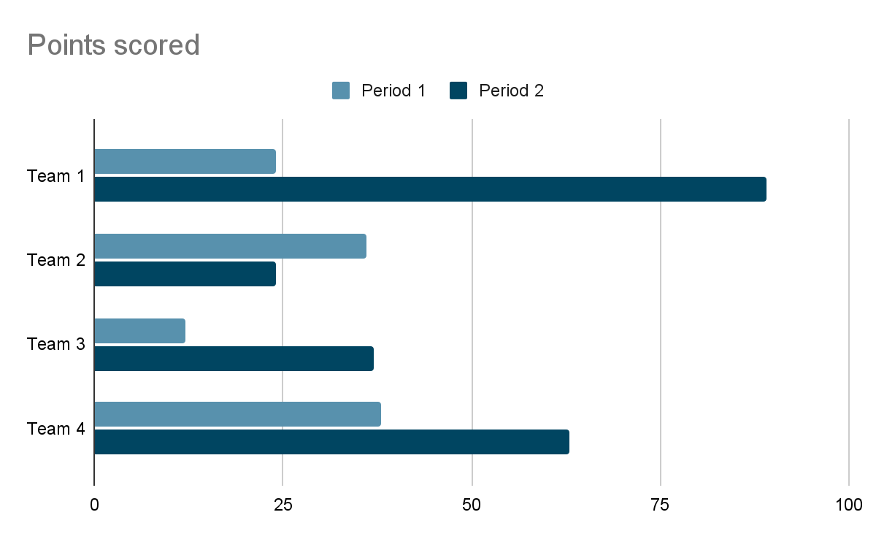

COMPONENT DIAGRAM:
A component diagram, also known as a 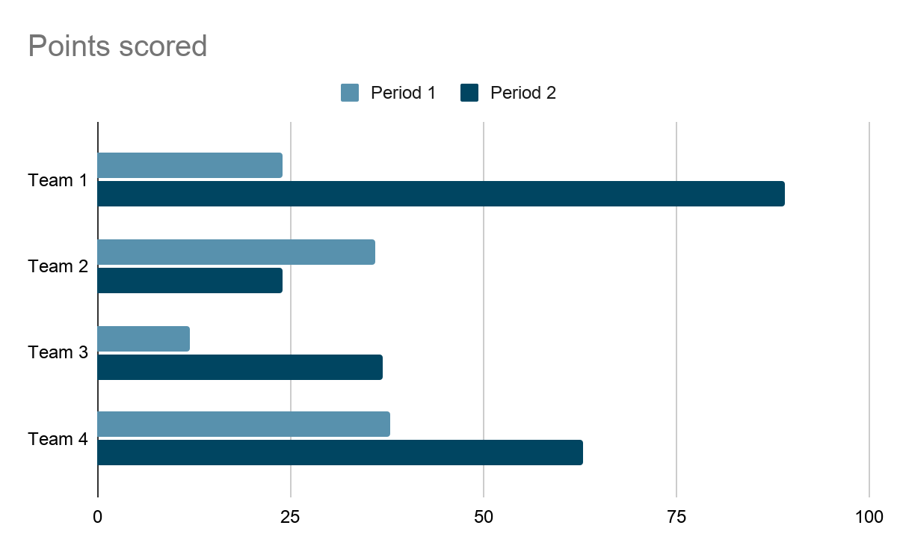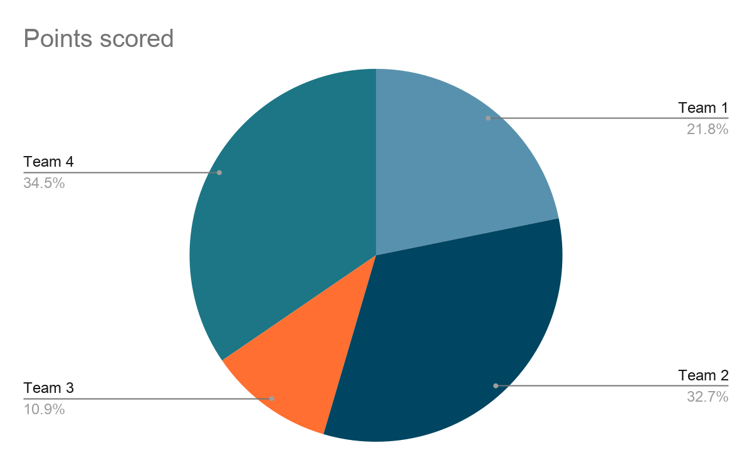 component diagram, describes the organization and wiring of the physical components in a system. Component diagrams are often drawn to help model implementation details and doublecheck that every aspect of the system's required function is covered by planned development.
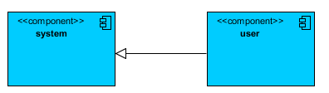

ER DIAGRAM:
An Entity–relationship model (ER model) describes the structure of a database with the help of a diagram, which is known as Entity Relationship Diagram (ER Diagram). An ER model is a design or blueprint of a database that can later be implemented as a database. The main components of ER model are: entity set and relationship set.
An ER diagram shows the relationship among entity sets. An entity set is a group of similar entities and these entities can have attributes. In terms of DBMS, an entity is a table or attribute of a table in database, so by showing relationship among tables and their attributes, ER diagram shows the complete logical structure of a database. Let’s have a look at a simple ER diagram to understand this concept.
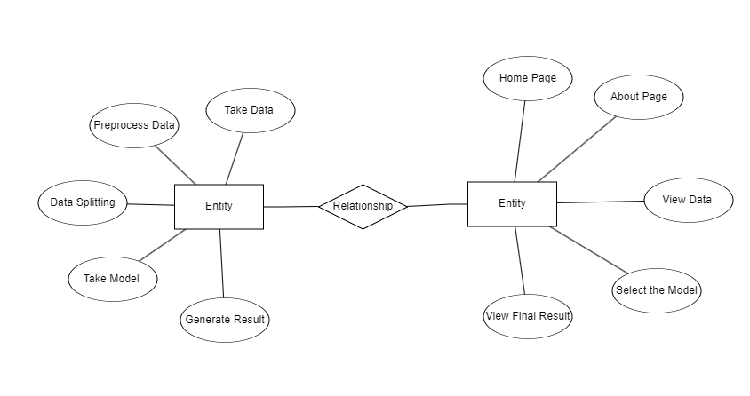
DFD DIAGRAM:
A Data Flow Diagram (DFD) is a traditional way to visualize the information flows within a system. A neat and clear DFD can depict a good amount of the system requirements graphically. It can be manual, automated, or a combination of both. It shows how information enters and leaves the system, what changes the information and where information is stored. The purpose of a DFD is to show the scope and boundaries of a system as a whole. It may be used as a communications tool between a systems analyst and any person who plays a part in the system that acts as the starting point for redesigning a system.
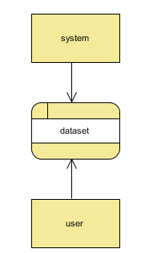

Level 1:
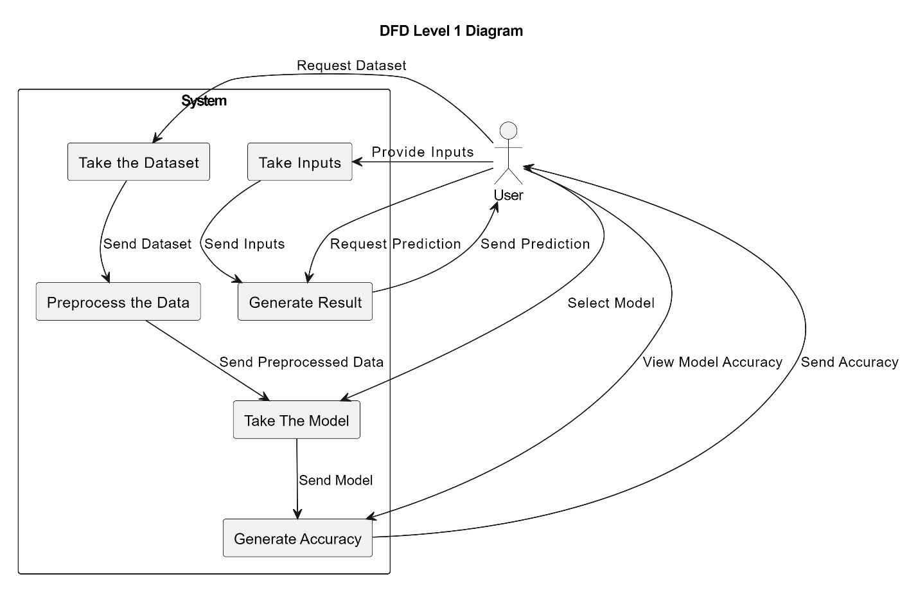

Level 2:

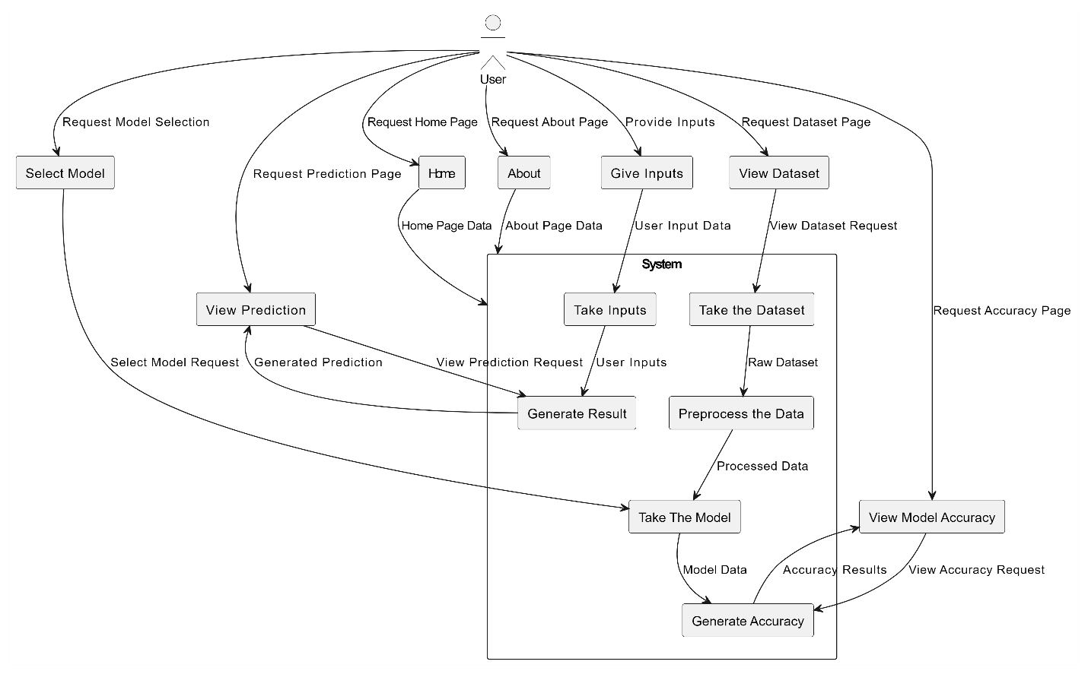

6. IMPLEMENTATION AND RESULTS
MODULES:
- User:
  - View data:
In the view data, the user will View the dataset for modelling.
  - Input Model:
The user must provide input values for the certain fields in order to get results.
  - View Results:
User view’s the generated results from the model.
  - View score:
Here user have ability to view the accuracy in %

- System
  - Working on dataset:
System checks for data whether it is available or not and load the data in csv files.
  - Pre-processing:
Data need to be pre-processed according the models it helps to increase the accuracy of the model and better information about the data.
  - Training the data:
After pre-processing the data will split into two parts as train and test data before training with the given algorithms.
  - Model Building
To create a model that predicts the personality with better accuracy, this module will help user.
  - Generated Score:
Here user view the score in %
  - Generate the Result:
Person has a Parkinson Disease or Not

OUTPUT SCREENS OVERVIEW
Home: Welcome to Parkinson Disease Detection.
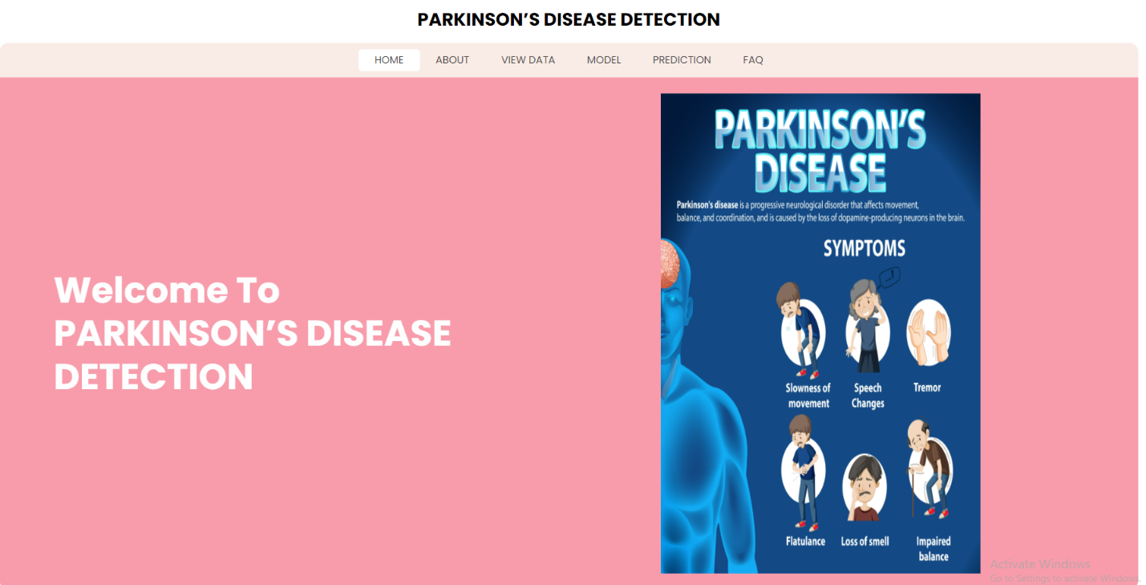

About: Here is some information related your project.
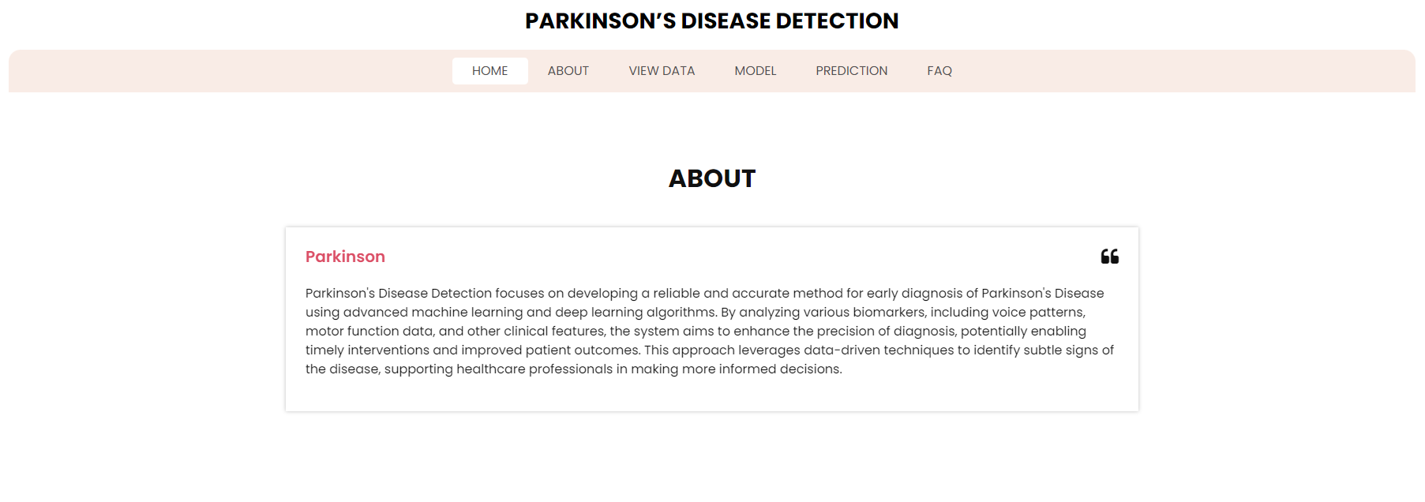

View: Here user can see the dataset columns and row format which type of data is present.
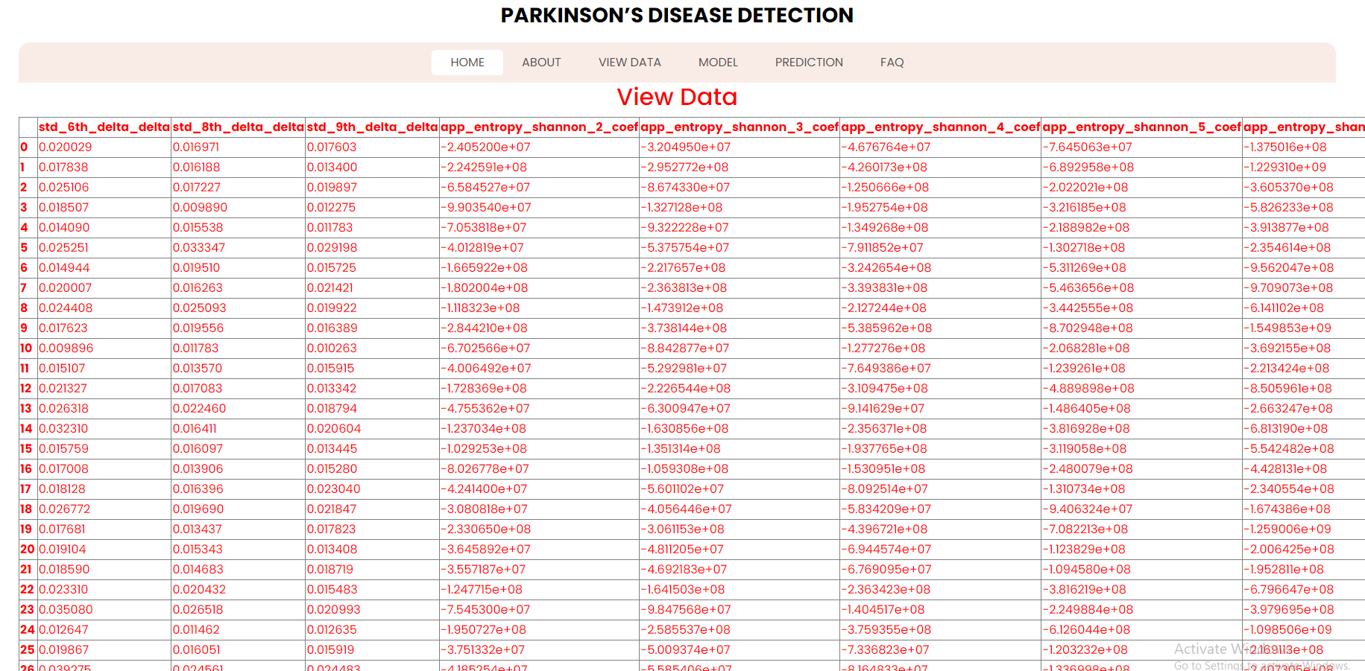

Training: We’re training the algorithm to see which one has the best accuracy.
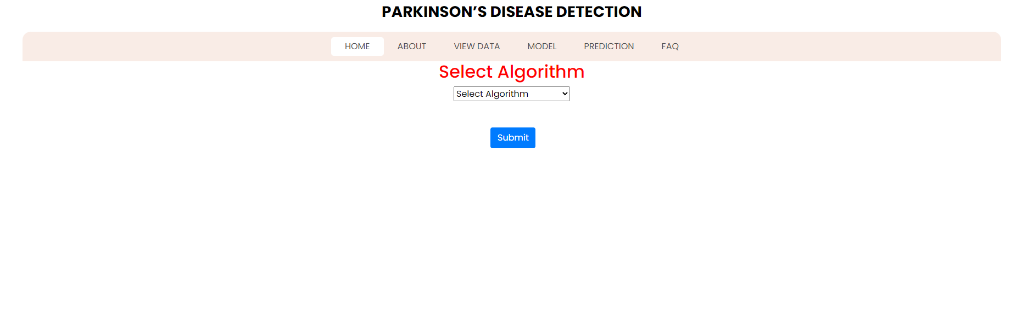

Prediction: This page shows the final output of user input.
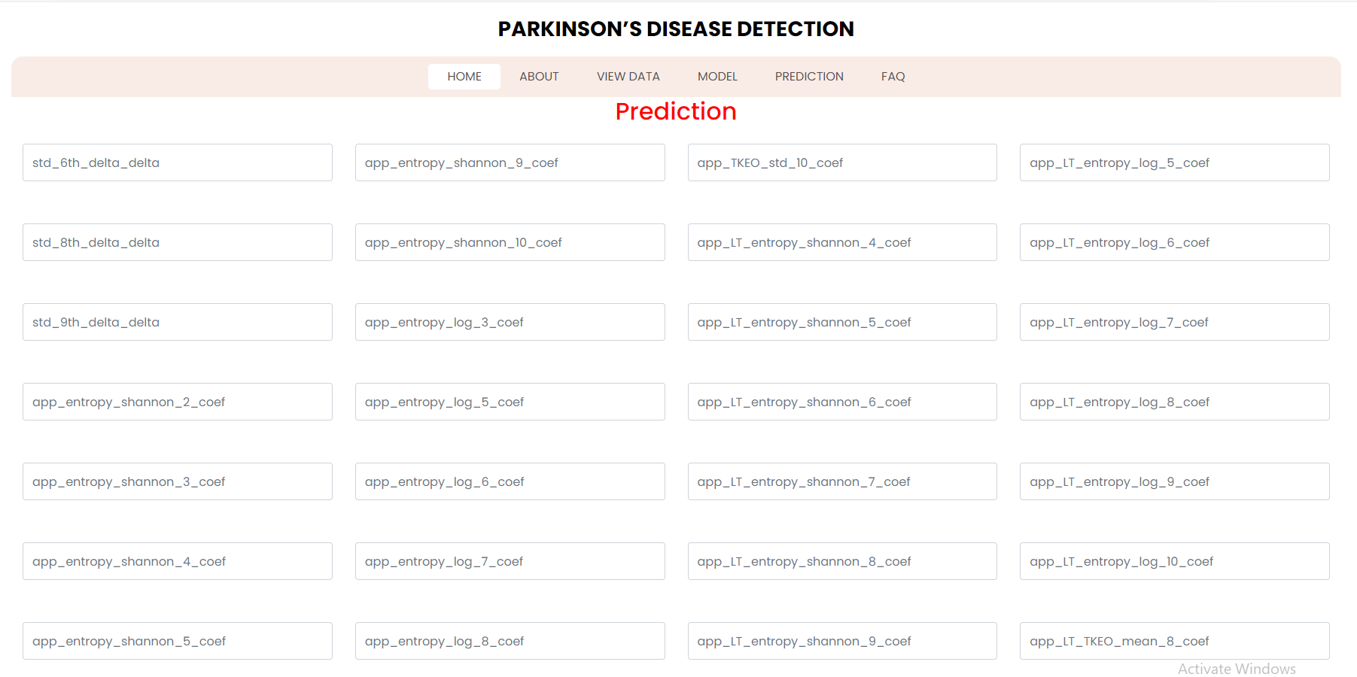

FAQ: Here is FAQ User have to select Question It will show the Answer.
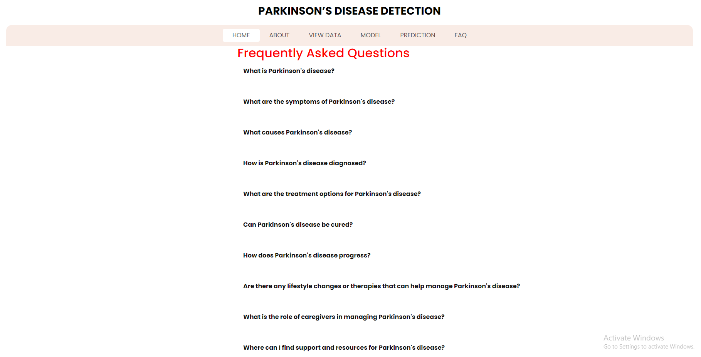

7. TEST CASES:
Input | Output | Result
Input | Tested for different model given by user on the different model. | Success
Random Forest Classifier | Tested for different input given by the user on different models are created using the different algorithm and data. | Success
Prediction | Prediction will be performed using to build from the algorithm. | Success

  - Test cases Model building:
S.NO | Test cases | I/O | Expected O/T | Actual O/T | P/F
1 | Read the datasets. | Dataset’s path. | Datasets need to read successfully. | Datasets fetched successfully. | It produced P. If this not F will come in case the data is not in the form of .csv
2 | Feature engineering | Need to check the dataset null values/categorical values | Dataset Pre processed successfully | Data wrangled successfully | It produced P. If this not F will come
3 | Modelling | Input with algorithms to get metrics | Algorithm accuracy will be in the form of percentage | We can get the accuracy of each and every model one by one | It produced P. If this is not, it will undergo F
4 | Prediction | Need to enter the Numeric input. | Need to predict the output based on the user input | Result successfully predicted with particular algorithm | It produced P. If this is not, it will undergo F

8.CONCLUSION:
The detection of Parkinson's Disease through the analysis of speech features using deep learning techniques has demonstrated significant potential in improving diagnostic accuracy. By employing Convolutional Neural Networks (CNN), Support Vector Machines (SVM), and Random Forest algorithms, this project effectively identifies key speech characteristics associated with Parkinson's Disease, such as frequency, intensity, and timing. Early detection facilitated by these models not only enhances clinical decision-making but also provides patients with more timely treatment options, ultimately improving their quality of life and reducing long-term healthcare costs. The promising results underscore the importance of integrating machine learning into healthcare for the early detection and management of neurodegenerative disorders like Parkinson's Disease.

9.FUTURE ENHANCEMENTS:
In the future, this project can be expanded to include additional modalities such as gait analysis, handwriting patterns, and brain imaging data to improve the accuracy and robustness of Parkinson's Disease detection. Integrating advanced deep learning models like Recurrent Neural Networks (RNNs) or Transformer architectures could further enhance the system's ability to capture complex temporal patterns in speech and other data types. Additionally, deploying the model in a mobile or web-based application would facilitate real-time monitoring and early diagnosis for patients in remote areas, thus broadening access to early detection and intervention. Collaboration with healthcare professionals for continuous feedback could also lead to personalized treatment strategies and improved patient outcomes.

References:
1] Abirami S., Chitra P. (2020). Energy-efficient edge based real-time healthcare support system. Adv. Comp. 117, 339–368. 10.1016/bs.adcom.2019.09.007 [CrossRef] [Google Scholar]
2] Al-Fatlawi A. H., Jabardi M. H., Ling S. H. (2016). “Efficient diagnosis system for parkinson's disease using deep belief network,” in 2016 IEEE Congress on evolutionary computation (CEC) (Vancouver, BC, Canada: IEEE; ), 1324–1330. 10.1109/CEC.2016.7743941 [CrossRef] [Google Scholar]
3] Bilgen I., Guvercin G., Rekik I. (2020). Machine learning methods for brain network classification: application to autism diagnosis using cortical morphological networks. J. Neurosci. Meth. 343, 108799. 10.1016/j.jneumeth.2020.108799 [PubMed] [CrossRef] [Google Scholar]
4] Charbuty B., Abdulazeez A. (2021). Classification based on decision tree algorithm for machine learning. J. Appl. Sci. Technol. Trends. 2, 20–28. 10.38094/jastt20165 [CrossRef] [Google Scholar]
5] Das R. (2010). A comparison of multiple classification methods for diagnosis of parkinson disease. Expert Syst. Appl. 37, 1568–1572. 10.1016/j.eswa.2009.06.040 [CrossRef] [Google Scholar]
6] Desai R. (2019). Top 10 Python Libraries for Data Science. Available online at: https://towardsdatascience.com/top-10-python-libraries-for-data-science-cd82294ec266 (accessed July 3, 2022).
7] Fothergill-Misbah N., Maroo H., Hooker J., Kwasa J., Walker R. (2020). Parkinson's disease medication in kenya–situation analysis. Pharmaceutica l J. Kenya. 24, 38–41. [Google Scholar]
8] Gil D., Manuel D. J. (2009). Diagnosing parkinson by using artificial neural networks and support vector machines. Glob. J. Comput. Sci. Technol. 9, 63–71. Available online at: http://citeseerx.ist.psu.edu/viewdoc/download?doi=10.1.1.182.7856&rep=rep1&type=pdf
9] Harel B., Cannizzaro M., Snyder P. J. (2004). Variability in fundamental frequency during speech in prodromal and incipient parkinson's disease: a longitudinal case study. Brain Cognit. 56, 24–29. 10.1016/j.bandc.2004.05.002 [PubMed] [CrossRef] [Google Scholar]
10] Hossain E., Hossain M. F., Rahaman M. A. (2019). “A color and texture based approach for the detection and classification of plant leaf disease using knn classifier,” in 2019 International Conference on Electrical, Computer and Communication Engineering (ECCE) (Cox's Bazar: IEEE; ), 1–6. 10.1109/ECACE.2019.8679247 [CrossRef] [Google Scholar]

BIBLIOGRAPHY:

SOFTWARE INSTALLATION FOR MACHINE LEARNING PROJECTS:
Installing Python:
- To download and install Python visit the official website of Python https://www.python.org/downloads/ and choose your version.
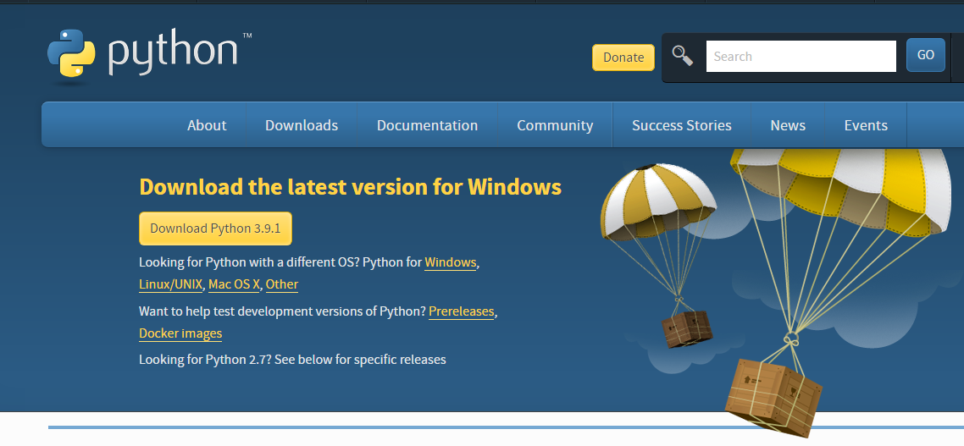
- Once the download is complete, run the exe for install Python. Now click on Install Now.
- You can see Python installing at this point.
- When it finishes, you can see a screen that says the Setup was successful. Now click on "Close".
Installing PyCharm:
- To download PyCharm visit the website https://www.jetbrains.com/pycharm/download/ and click the "DOWNLOAD" link under the Community Section.
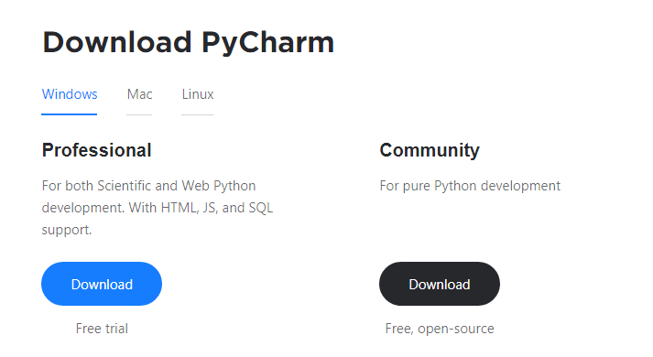
- Once the download is complete, run the exe for install PyCharm. The setup wizard should have started. Click “Next”.
- On the next screen, Change the installation path if required. Click “Next”.
- On the next screen, you can create a desktop shortcut if you want and click on “Next”.
- Choose the start menu folder. Keep selected JetBrains and click on “Install”.
- Wait for the installation to finish.
- Once installation finished, you should receive a message screen that PyCharm is installed. If you want to go ahead and run it, click the “Run PyCharm Community Edition” box first and click “Finish”.
- After you click on "Finish," the Following screen will appear.
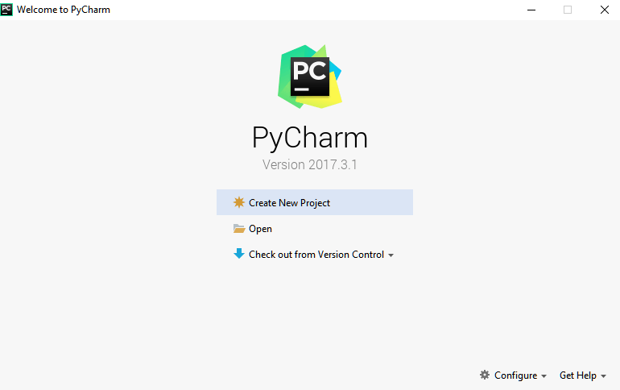
9. You need to install some packages to execute your project in a proper way.
10. Open the command prompt/ anaconda prompt or terminal as administrator.
11. The prompt will get open, with specified path, type “pip install package name” which you want to install (like NumPy, pandas, sea born, scikitlearn, Matplotlib, Pyplot)
Ex: Pip install NumPy
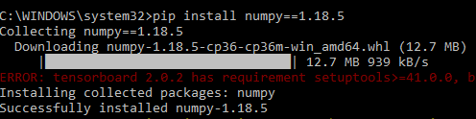

INTRODUCTION TO PYTHON

- Python

What Is a Script?
Up to this point, I have concentrated on the interactive programming capability of Python. This is a very useful capability that allows you to type in a program and to have it executed immediately in an interactive mode
Scripts are reusable
Basically, a script is a text file containing the statements that comprise a Python program. Once you have created the script, you can execute it over and over without having to retype it each time.
Scripts are editable
Perhaps, more importantly, you can make different versions of the script by modifying the statements from one file to the next using a text editor. Then you can execute each of the individual versions. In this way, it is easy to create different programs with a minimum amount of typing.
You will need a text editor
Just about any text editor will suffice for creating Python script files.
You can use Microsoft Notepad, Microsoft WordPad, Microsoft Word, or just about any word processor if you want to.

Difference between a script and a program
Script:
Scripts are distinct from the core code of the application, which is usually written in a different language, and are often created or at least modified by the enduser. Scripts are often interpreted from source code or byte code, whereas the applications they control are traditionally compiled to native machine code.

Program:
The program has an executable form that the computer can use directly to execute the instructions.
The same program in its humanreadable source code form, from which executable programs are derived (e.g., compiled)
Python
What is Python? Chances you are asking yourself this. You may have found this book because you want to learn to program but don’t know anything about programming languages. Or you may have heard of programming languages like C, C++, C#, or Java and want to know what Python is and how it compares to “big name” languages. Hopefully I can explain it for you.
Python concepts
If you’re not interested in the how’s and whys of Python, feel free to skip to the next chapter. In this chapter I will try to explain to the reader why I think Python is one of the best languages available and why it’s a great one to start programming with.
• Opensource generalpurpose language.
• Object Oriented, Procedural, Functional
• Easy to interface with C/ObjC/Java/Fortran
• Easyis to interface with C++ (via SWIG)
• Great interactive environment
• Great interactive environment
Python is a highlevel, interpreted, interactive and objectoriented scripting language. Python is designed to be highly readable. It uses English keywords frequently where as other languages use punctuation, and it has fewer syntactical constructions than other languages.
- Python is Interpreted − Python is processed at runtime by the interpreter. You do not need to compile your program before executing it. This is similar to PERL and PHP.
- Python is Interactive − you can actually sit at a Python prompt and interact with the interpreter directly to write your programs.
- Python is ObjectOriented − Python supports ObjectOriented style or technique of programming that encapsulates code within objects.
- Python is a Beginner's Language − Python is a great language for the beginnerlevel programmers and supports the development of a wide range of applications from simple text processing to WWW browsers to games.

History of Python
Python was developed by Guido van Possum in the late eighties and early nineties at the National Research Institute for Mathematics and Computer Science in the Netherlands.
Python is derived from many other languages, including ABC, Modula3, C, C++, Algol68, Smalltalk, and UNIX shell and other scripting languages.
Python is copyrighted. Like Perl, Python source code is now available under the GNU General Public License (GPL).
Python is now maintained by a core development team at the institute, although Guido van Possum still holds a vital role in directing its progress.
Python Features
Python's features include −
- Easytolearn − Python has few keywords, simple structure, and a clearly defined syntax. This allows the student to pick up the language quickly.
- Easytoread − Python code is more clearly defined and visible to the eyes.
- Easytomaintain − Python's source code is fairly easytomaintained.
- A broad standard library − Python's bulk of the library is very portable and crossplatform compatible on UNIX, Windows, and Macintosh.
- Interactive Mode − Python has support for an interactive mode which allows interactive testing and debugging of snippets of code.
- Portable − Python can run on a wide variety of hardware platforms and has the same interface on all platforms.
- Extendable − you can add lowlevel modules to the Python interpreter. These modules enable programmers to add to or customize their tools to be more efficient.
- Databases − Python provides interfaces to all major commercial databases.
- GUI Programming − Python supports GUI applications that can be created and ported to many system calls, libraries and windows systems, such as Windows MFC, Macintosh, and the X Window system of Unix.
- Scalable − Python provides a better structure and support for large programs than shell scripting.

Apart from the abovementioned features, Python has a big list of good features, few are listed below −
- It supports functional and structured programming methods as well as OOP.
- It can be used as a scripting language or can be compiled to bytecode for building large applications.
- It provides very highlevel dynamic data types and supports dynamic type checking.
- IT supports automatic garbage collection.
- It can be easily integrated with C, C++, COM, ActiveX, CORBA, and Java.

Dynamic vs. Static
Types Python is a dynamictyped language. Many other languages are static typed, such as C/C++ and Java. A static typed language requires the programmer to explicitly tell the computer what type of “thing” each data value is.
For example, in C if you had a variable that was to contain the price of something, you would have to declare the variable as a “float” type.
This tells the compiler that the only data that can be used for that variable must be a floating point number, i.e. a number with a decimal point.
If any other data value was assigned to that variable, the compiler would give an error when trying to compile the program.
Python, however, doesn’t require this. You simply give your variables names and assign values to them. The interpreter takes care of keeping track of what kinds of objects your program is using. This also means that you can change the size of the values as you develop the program. Say you have another decimal number (a.k.a. a floating point number) you need in your program.
With a static typed language, you have to decide the memory size the variable can take when you first initialize that variable. A double is a floating point value that can handle a much larger number than a normal float (the actual memory sizes depend on the operating environment).
If you declare a variable to be a float but later on assign a value that is too big to it, your program will fail; you will have to go back and change that variable to be a double.
With Python, it doesn’t matter. You simply give it whatever number you want and Python will take care of manipulating it as needed. It even works for derived values.
For example, say you are dividing two numbers. One is a floating point number and one is an integer. Python realizes that it’s more accurate to keep track of decimals so it automatically calculates the result as a floating point number
Variables
Variables are nothing but reserved memory locations to store values. This means that when you create a variable you reserve some space in memory.
Based on the data type of a variable, the interpreter allocates memory and decides what can be stored in the reserved memory. Therefore, by assigning different data types to variables, you can store integers, decimals or characters in these variables.
Standard Data Types
The data stored in memory can be of many types. For example, a person's age is stored as a numeric value and his or her address is stored as alphanumeric characters. Python has various standard data types that are used to define the operations possible on them and the storage method for each of them.
Python has five standard data types −
- Numbers
- String
- List
- Tuple
- Dictionary

Python Numbers
Number data types store numeric values. Number objects are created when you assign a value to them

Python Strings

Strings in Python are identified as a contiguous set of characters represented in the quotation marks. Python allows for either pairs of single or double quotes. Subsets of strings can be taken using the slice operator ([ ] and [:]) with indexes starting at 0 in the beginning of the string and working their way from 1 at the end.

Python Lists

Lists are the most versatile of Python's compound data types. A list contains items separated by commas and enclosed within square brackets ([]). To some extent, lists are similar to arrays in C. One difference between them is that all the items belonging to a list can be of different data type.
The values stored in a list can be accessed using the slice operator ([ ] and [:]) with indexes starting at 0 in the beginning of the list and working their way to end 1. The plus (+) sign is the list concatenation operator, and the asterisk () is the repetition operator.

Python Tuples

A tuple is another sequence data type that is similar to the list. A tuple consists of a number of values separated by commas. Unlike lists, however, tuples are enclosed within parentheses.
The main differences between lists and tuples are: Lists are enclosed in brackets ([ ]) and their elements and size can be changed, while tuples are enclosed in parentheses (( )) and cannot be updated. Tuples can be thought of as readonly lists.

Python Dictionary
Python's dictionaries are kind of hash table type. They work like associative arrays or hashes found in Perl and consist of keyvalue pairs. A dictionary key can be almost any Python type, but are usually numbers or strings. Values, on the other hand, can be any arbitrary Python object.
Dictionaries are enclosed by curly braces ({ }) and values can be assigned and accessed using square braces ([]).

Different modes in python

Python has two basic modes: normal and interactive.
The normal mode is the mode where the scripted and finished .pie files are run in the Python interpreter.
Interactive mode is a command line shell which gives immediate feedback for each statement, while running previously fed statements in active memory. As new lines are fed into the interpreter, the fed program is evaluated both in part and in whole

20 Python libraries

1. Requests. The most famous http library written by Kenneth remits. It’s a must have for every python developer.
2. Scrappy. If you are involved in web scraping then this is a must have library for you. After using this library you won’t use any other.
3. Python. A guy toolkit for python. I have primarily used it in place of tinder. You will really love it.
4. Pillow. A friendly fork of PIL (Python Imaging Library). It is more user friendly than PIL and is a must have for anyone who works with images.
5. SQL Alchemy. A database library. Many love it and many hate it. The choice is yours.
6. Beautiful Soup. I know it’s slow but this xml and html parsing library is very useful for beginners.
7. Twisted. The most important tool for any network application developer. It has a very beautiful ape and is used by a lot of famous python developers.
8. Numbly. How can we leave this very important library? It provides some advance math functionalities to python.
9. Skippy. When we talk about numbly then we have to talk about spicy. It is a library of algorithms and mathematical tools for python and has caused many scientists to switch from ruby to python.
10. Matplotlib. A numerical plotting library. It is very useful for any data scientist or any data analyser.
11. Pygmy. Which developer does not like to play games and develop them? This library will help you achieve your goal of 2d game development.
12. Piglet. A 3d animation and game creation engine. This is the engine in which the famous python port of mine craft was made
13. Pit. A GUI toolkit for python. It is my second choice after python for developing GUI’s for my python scripts.
14. Pit. Another python GUI library. It is the same library in which the famous Bit torrent client is created.
15. Scaly. A packet sniffer and analyser for python made in python.
16. Pywin32. A python library which provides some useful methods and classes for interacting with windows.
17. Notch. Natural Language Toolkit – I realize most people won’t be using this one, but it’s generic enough. It is a very useful library if you want to manipulate strings. But its capacity is beyond that. Do check it out.
18. Nose. A testing framework for python. It is used by millions of python developers. It is a must have if you do test driven development.
19. Simply. Simply cando algebraic evaluation, differentiation, expansion, complex numbers, etc. It is contained in a pure Python distribution.
20. I Python. I just can’t stress enough how useful this tool is. It is a python prompt on steroids. It has completion, history, shell capabilities, and a lot more. Make sure that you take a look at it.

NumPy
Humpy’s main object is the homogeneous multidimensional array. It is a table of elements (usually numbers), all of the same type, indexed by a tuple of positive integers. In numbly dimensions are called axes. The number of axes is rank.
• Offers Matlabish capabilities within Python
• Fast array operations
• 2D arrays, multiD arrays, linear algebra etc.

Matplotlib
• High quality plotting library.
Python class and objects
These are the building blocks of OOP. Class creates a new object. This object can be anything, whether an abstract data concept or a model of a physical object, e.g. a chair. Each class has individual characteristics unique to that class, including variables and methods. Classes are very powerful and currently “the big thing” in most programming languages. Hence, there are several chapters dedicated to OOP later in the book.
The class is the most basic component of objectoriented programming. Previously, you learned how to use functions to make your program do something.
Now will move into the big, scary world of ObjectOriented Programming (OOP). To be honest, it took me several months to get a handle on objects.
When I first learned C and C++, I did great; functions just made sense for me.
Having messed around with BASIC in the early ’90s, I realized functions were just like subroutines so there wasn’t much new to learn.
However, when my C++ course started talking about objects, classes, and all the new features of OOP, my grades definitely suffered.
Once you learn OOP, you’ll realize that it’s actually a pretty powerful tool. Plus many Python libraries and APIs use classes, so you should at least be able to understand what the code is doing.
One thing to note about Python and OOP: it’s not mandatory to use objects in your code in a way that works best; maybe you don’t need to have a fullblown class with initialization code and methods to just return a calculation. With Python, you can get as technical as you want.
As you’ve already seen, Python can do just fine with functions. Unlike languages such as Java, you aren’t tied down to a single way of doing things; you can mix functions and classes as necessary in the same program. This lets you build the code
Objects are an encapsulation of variables and functions into a single entity. Objects get their variables and functions from classes. Classes are essentially a template to create your objects.
Here’s a brief list of Python OOP ideas:
• The class statement creates a class object and gives it a name. This creates a new namespace.
• Assignments within the class create class attributes. These attributes are accessed by qualifying the name using dot syntax: ClassName.Attribute.
• Class attributes export the state of an object and its associated behaviour. These attributes are shared by all instances of a class.
• Calling a class (just like a function) creates a new instance of the class.
This is where the multiple copy’s part comes in.
• Each instance gets ("inherits") the default class attributes and gets its own namespace. This prevents instance objects from overlapping and confusing the program.
• Using the term self identifies a particular instance, allowing for perinstance attributes. This allows items such as variables to be associated with a particular instance.

Inheritance
First off, classes allow you to modify a program without really making changes to it.
To elaborate, by sub classing a class, you can change the behaviour of the program by simply adding new components to it rather than rewriting the existing components.
As we’ve seen, an instance of a class inherits the attributes of that class.
However, classes can also inherit attributes from other classes. Hence, a subclass inherits from a superclass allowing you to make a generic superclass that is specialized via subclasses.
The subclasses can override the logic in a superclass, allowing you to change the behaviour of your classes without changing the superclass at all.
Operator Overloads
Operator overloading simply means that objects that you create from classes can respond to actions (operations) that are already defined within Python, such as addition, slicing, printing, etc.
Even though these actions can be implemented via class methods, using overloading ties the behavior closer to Python’s object model and the object interfaces are more consistent to Python’s builtin objects, hence overloading is easier to learn and use.
Usermade classes can override nearly all of Python’s builtin operation methods
Exceptions
I’ve talked about exceptions before but now I will talk about them in depth. Essentially, exceptions are events that modify program’s flow, either intentionally or due to errors.
They are special events that can occur due to an error, e.g. trying to open a file that doesn’t exist, or when the program reaches a marker, such as the completion of a loop.
Exceptions, by definition, don’t occur very often; hence, they are the "exception to the rule" and a special class has been created for them. Exceptions are everywhere in Python.
Virtually every module in the standard Python library uses them, and Python itself will raise them in a lot of different circumstances.
Here are just a few examples:
• Accessing a non−existent dictionary key will raise a Key Error exception.
• Searching a list for a non−existent value will raise a Value Error exception
. • Calling a non−existent method will raise an Attribute Error exception.
• Referencing a non−existent variable will raise a Name Error exception.
• Mixing data types without coercion will raise a Type Error exception.
One use of exceptions is to catch a fault and allow the program to continue working; we have seen this before when we talked about files.
This is the most common way to use exceptions. When programming with the Python command line interpreter, you don’t need to worry about catching exceptions.
Your program is usually short enough to not be hurt too much if an exception occurs.
Plus, having the exception occur at the command line is a quick and easy way to tell if your code logic has a problem.
However, if the same error occurred in your real program, it will fail and stop working. Exceptions can be created manually in the code by raising an exception.
It operates exactly as a systemcaused exceptions, except that the programmer is doing it on purpose. This can be for a number of reasons. One of the benefits of using exceptions is that, by their nature, they don’t put any overhead on the code processing.
Because exceptions aren’t supposed to happen very often, they aren’t processed until they occur.
Exceptions can be thought of as a special form of the if/elf statements. You can realistically do the same thing with if blocks as you can with exceptions.
However, as already mentioned, exceptions aren’t processed until they occur; if blocks are processed all the time.
Proper use of exceptions can help the performance of your program.
The more infrequent the error might occur, the better off you are to use exceptions; using if blocks requires Python to always test extra conditions before continuing.
Exceptions also make code management easier: if your programming logic is mixed in with errorhandling if statements, it can be difficult to read, modify, and debug your program.
UserDefined Exceptions
I won’t spend too much time talking about this, but Python does allow for a programmer to create his own exceptions.
You probably won’t have to do this very often but it’s nice to have the option when necessary.
However, before making your own exceptions, make sure there isn’t one of the builtin exceptions that will work for you.
They have been "tested by fire" over the years and not only work effectively, they have been optimized for performance and are bugfree.
Making your own exceptions involves objectoriented programming, which will be covered in the next chapter
. To make a custom exception, the programmer determines which base exception to use as the class to inherit from, e.g. making an exception for negative numbers or one for imaginary numbers would probably fall under the Arithmetic Error exception class.
To make a custom exception, simply inherit the base exception and define what it will do.
Python modules
Python allows us to store our code in files (also called modules). This is very useful for more serious programming, where we do not want to retype a long function definition from the very beginning just to change one mistake. In doing this, we are essentially defining our own modules, just like the modules defined already in the Python library.
To support this, Python has a way to put definitions in a file and use them in a script or in an interactive instance of the interpreter. Such a file is called a module; definitions from a module can be imported into other modules or into the main module.
Testing code
As indicated above, code is usually developed in a file using an editor.
To test the code, import it into a Python session and try to run it.
Usually there is an error, so you go back to the file, make a correction, and test again.
This process is repeated until you are satisfied that the code works. T
His entire process is known as the development cycle.
There are two types of errors that you will encounter. Syntax errors occur when the form of some command is invalid.
This happens when you make typing errors such as misspellings, or call something by the wrong name, and for many other reasons. Python will always give an error message for a syntax error.

Functions in Python
It is possible, and very useful, to define our own functions in Python. Generally speaking, if you need to do a calculation only once, then use the interpreter. But when you or others have need to perform a certain type of calculation many times, then define a function.
You use functions in programming to bundle a set of instructions that you want to use repeatedly or that, because of their complexity, are better selfcontained in a subprogram and called when needed. That means that a function is a piece of code written to carry out a specified task.

To carry out that specific task, the function might or might not need multiple inputs. When the task is carved out, the function can or cannot return one or more values.

There are three types of functions in python:

Help (), min (), print ().
Namespaces in Python are implemented as Python dictionaries, this means it is a mapping from names (keys) to objects (values). The user doesn't have to know this to write a Python program and when using namespaces.
Some namespaces in Python:
- global names of a module
- local names in a function or method invocation
- builtin names: this namespace contains builtin functions (e.g. abs(), camp(), ...) and builtin exception names
Garbage Collection
Garbage Collector exposes the underlying memory management mechanism of Python, the automatic garbage collector. The module includes functions for controlling how the collector operates and to examine the objects known to the system, either pending collection or stuck in reference cycles and unable to be freed.
Python XML Parser
XML is a portable, open source language that allows programmers to develop applications that can be read by other applications, regardless of operating system and/or developmental language.
What is XML? The Extensible Markup Language XML is a markup language much like HTML or SGML.
This is recommended by the World Wide Web Consortium and available as an open standard.
XML is extremely useful for keeping track of small to medium amounts of data without requiring a SQLbased backbone.
XML Parser Architectures and APIs the Python standard library provides a minimal but useful set of interfaces to work with XML.
The two most basic and broadly used APIs to XML data are the SAX and DOM interfaces.
Simple API for XML SAX: Here, you register callbacks for events of interest and then let the parser proceed through the document.
This is useful when your documents are large or you have memory limitations, it parses the file as it reads it from disk and the entire file is never stored in memory.
Document Object Model DOM API : This is a World Wide Web Consortium recommendation wherein the entire file is read into memory and stored in a hierarchical tree − based form to represent all the features of an XML document.
SAX obviously cannot process information as fast as DOM can when working with large files. On the other hand, using DOM exclusively can really kill your resources, especially if used on a lot of small files.
SAX is readonly, while DOM allows changes to the XML file. Since these two different APIs literally complement each other, there is no reason why you cannot use them both for large projects.

Python Web Frameworks
A web framework is a code library that makes a developer's life easier when building reliable, scalable and maintainable web applications.

Why are web frameworks useful?
Web frameworks encapsulate what developers have learned over the past twenty years while programming sites and applications for the web. Frameworks make it easier to reuse code for common HTTP operations and to structure projects so other developers with knowledge of the framework can quickly build and maintain the application.
Common web framework functionality
Frameworks provide functionality in their code or through extensions to perform common operations required to run web applications. These common operations include:
- URL routing
- HTML, XML, JSON, and other output format tinplating
- Database manipulation
- Security against Crosssite request forgery (CSRF) and other attacks
- Session storage and retrieval
Not all web frameworks include code for all of the above functionality. Frameworks fall on the spectrum from executing a single use case to providing every known web framework feature to every developer. Some frameworks take the "batteriesincluded" approach where everything possible comes bundled with the framework while others have a minimal core package that is amenable to extensions provided by other packages.

Comparing web frameworks
There is also a repository called comparepythonwebframeworks where the same web application is being coded with varying Python web frameworks, tinplating engines and object.

Web framework resources
- When you are learning how to use one or more web frameworks it's helpful to have an idea of what the code under the covers is doing.
- Frameworks is a really well done short video that explains how to choose between web frameworks. The author has some particular opinions about what should be in a framework. For the most part I agree although I've found sessions and database ORMs to be a helpful part of a framework when done well.
- What is a web framework? Is an indepth explanation of what web frameworks are and their relation to web servers?
- Jingo vs. Flash vs. Pyramid: Choosing a Python web framework contains background information and code comparisons for similar web applications built in these three big Python frameworks.
- This fascinating blog post takes a look at the code complexity of several Python web frameworks by providing visualizations based on their code bases.
- Python’s web frameworks benchmarks is a test of the responsiveness of a framework with encoding an object to JSON and returning it as a response as well as retrieving data from the database and rendering it in a template. There were no conclusive results but the output is fun to read about nonetheless.
- What web frameworks do you use and why are they awesome? Is a language agnostic Reedit discussion on web frameworks? It's interesting to see what programmers in other languages like and dislike about their suite of web frameworks compared to the main Python frameworks.
- This uservoted question & answer site asked "What are the best general purpose Python web frameworks usable in production?” The votes aren't as important as the list of the many frameworks that are available to Python developers.

Web frameworks learning checklist
- Choose a major Python web framework (Jingo or Flask are recommended) and stick with it. When you're just starting it's best to learn one framework first instead of bouncing around trying to understand every framework.
- Work through a detailed tutorial found within the resources links on the framework's page.
- Study open source examples built with your framework of choice so you can take parts of those projects and reuse the code in your application.
- Build the first simple iteration of your web application then go to the deployment section to make it accessible on the web.
2. SYSTEM STUDY

SYSTEM TESTING
The purpose of testing is to discover errors. Testing is the process of trying to discover every conceivable fault or weakness in a work product. It provides a way to check the functionality of components, subassemblies, assemblies and/or a finished product It is the process of exercising software with the intent of ensuring that the
Software system meets its requirements and user expectations and does not fail in an unacceptable manner. There are various types of test. Each test type addresses a specific testing requirement.

TYPES OF TESTS
Unit testing
Unit testing involves the design of test cases that validate that the internal program logic is functioning properly, and that program inputs produce valid outputs. All decision branches and internal code flow should be validated. It is the testing of individual software units of the application .it is done after the completion of an individual unit before integration. This is a structural testing, that relies on knowledge of its construction and is invasive. Unit tests perform basic tests at component level and test a specific business process, application, and/or system configuration. Unit tests ensure that each unique path of a business process performs accurately to the documented specifications and contains clearly defined inputs and expected results.
Integration testing
Integration tests are designed to test integrated software components to determine if they actually run as one program. Testing is event driven and is more concerned with the basic outcome of screens or fields. Integration tests demonstrate that although the components were individually satisfaction, as shown by successfully unit testing, the combination of components is correct and consistent. Integration testing is specifically aimed at exposing the problems that arise from the combination of components.
Functional test
Functional tests provide systematic demonstrations that functions tested are available as specified by the business and technical requirements, system documentation, and user manuals.
Functional testing is centered on the following items:
Valid Input : identified classes of valid input must be accepted.
Invalid Input : identified classes of invalid input must be rejected.
Functions : identified functions must be exercised.
Output : identified classes of application outputs must be exercised.
Systems/Procedures: interfacing systems or procedures must be invoked.
Organization and preparation of functional tests is focused on requirements, key functions, or special test cases. In addition, systematic coverage pertaining to identify Business process flows; data fields, predefined processes, and successive processes must be considered for testing. Before functional testing is complete, additional tests are identified and the effective value of current tests is determined.
SYSTEM TEST
System testing ensures that the entire integrated software system meets requirements. It tests a configuration to ensure known and predictable results. An example of system testing is the configurationoriented system integration test. System testing is based on process descriptions and flows, emphasizing predriven process links and integration points.
White Box Testing
White Box Testing is a testing in which in which the software tester has knowledge of the inner workings, structure and language of the software, or at least its purpose. It is purpose. It is used to test areas that cannot be reached from a black box level.
Black Box Testing
Black Box Testing is testing the software without any knowledge of the inner workings, structure or language of the module being tested. Black box tests, as most other kinds of tests, must be written from a definitive source document, such as specification or requirements document, such as specification or requirements document. It is a testing in which the software under test is treated, as a black box. you cannot “see” into it. The test provides inputs and responds to outputs without considering how the software works.
6.1 Unit Testing:
Unit testing is usually conducted as part of a combined code and unit test phase of the software lifecycle, although it is not uncommon for coding and unit testing to be conducted as two distinct phases.
Test strategy and approach
Field testing will be performed manually and functional tests will be written in detail.
Test objectives
- All field entries must work properly.
- Pages must be activated from the identified link.
- The entry screen, messages and responses must not be delayed.
Features to be tested
- Verify that the entries are of the correct format
- No duplicate entries should be allowed
- All links should take the user to the correct page.

6.2 Integration Testing
Software integration testing is the incremental integration testing of two or more integrated software components on a single platform to produce failures caused by interface defects.
The task of the integration test is to check that components or software applications, e.g. components in a software system or – one step up – software applications at the company level – interact without error.
Test Results: All the test cases mentioned above passed successfully. No defects encountered.

6.3 Acceptance Testing
User Acceptance Testing is a critical phase of any project and requires significant participation by the end user. It also ensures that the system meets the functional requirements.
Test Results: All the test cases mentioned above passed successfully. No defects encountered.

